hi

Mid-Term Examination
(Fall, 2001-2002)

ENGG 201 - Behaviour of Liquids, Gases and Solids

October 24, 2001 Time Allowed: 90 minutes

1. Attempt all four (4) questions. Weighting as noted. Total marks =100.
- The text-book and electronic calculators are permitted. Notes are not allowed.
- Print your name clearly in the space provided on the cover page. Write your ID No. on the last page and all other pages in the provided space.

Surname:________________________Given Name(s):___________________ Section_____

STUDENT IDENTIFICATION
Each candidate must sign the Seating List confirming presence at the examination. All candidates for final examinations are required to place their University of Calgary student I.D. cards on their desks for the duration of the examination. (Students writing mid-term tests can also be asked to provide identity proof.) Students without an I.D. card who can produce an acceptable alternative I.D. e.g. one with a printed name and photograph, are allowed to write the examination.
A student without acceptable I.D. will be required to complete an Identification Form. The form indicates that there is no guarantee that the examination paper will be graded if any discrepancies in identification are discovered after verification with the student's file. A Student who refuses to produce identification or who refuses to complete and sign the Identification Form is not permitted to write the examination.

EXAMINATION RULES
(1) Students late in arriving will not normally be admitted after one-half hour of the examination time has passed.
(2) No candidate will be permitted to leave the examination room until one-half hour has elapsed after the opening of the examination, nor during the last 15 minutes of the examination. All candidates remaining during the last 15 minutes of the examination period must remain at their desks until their papers have been collected by an invigilator.
(3) All inquiries and requests must be addressed to supervisors only.
(4) Candidates are strictly cautioned against:
(a) Speaking to other candidates or communicating with them under any circumstances whatsoever: (b) bringing into the examination room any textbook, notebook or memoranda not authorized by the examiner;
(c) Making use of calculators and/or portable computing machines not authorized by the instructor: (d) leaving answer papers exposed to view;
(e) Attempting to read other student's examination papers.

The penalty for violation of these rules is suspension or expulsion or such other penalty as may be determined.
(5) Candidates are requested to write on both sides of the page, unless the examiner has asked that the left hand page be reserved for rough drafts or calculations.
(6) Discarded matter is to be struck out and not removed by mutilation of the examination answer book.
(7) Candidates are cautioned against writing in their answer book any matter extraneous to the actual answering of the question set.
(8) The candidate is to write his/her name on each answer book as directed and is to number each book.
(9) A candidate must report to a supervisor before leaving the examination room.
(10) Answer books must be handed to the supervisor-in-charge promptly when the signal is given. Failure to comply with this regulation will be cause for rejection of an answer paper.
(11) If during the course of an examination a student becomes ill or receives word of domestic affliction, the student should report at once to the supervisor, hand in the unfinished paper and request that it be cancelled. If physical and/or emotional ill health is the cause, the student must report at once to a physician/counsellor so that subsequent application for a deferred examination is supported by a completed Physician/Counsellor Statement form. Students can consult professionals at University Health Services or university Counselling Services during normal working hours or consult their physician/counsellor in the community.
Should a student write an examination, hand in the paper for marking, and later report extenuating circumstances to support a request for cancellation of the paper and for another examination, such a request will be denied.
(12) Smoking during examinations is strictly prohibited.

RO 93-02

PROBLEM I (20 points)
An ideal gas mixture was put together by mixing the contents of three vessels, each containing a single component ideal gas at the specified temperature and pressure listed below.
Vessel number | Component in the vessel | Molar Mass, (kg/kmol) | Volume of the vessel, (m³) | Temperature, (ºC) | Pressure, (kPa)
1 | CH₄ | 16 | 0.85 | 0 | 800
2 | CO₂ | 44 | 0.30 | 25 | 400
3 | N₂ | 28 | 0.35 | 35 | 600
The mixed gas was transferred to a fourth container whose volume was known to be 1.0 m³. The mixture was then heated to a temperature of 400 K. Calculate the following for this mixture:

- Number of moles of each component in the mixture.(4.5 points)
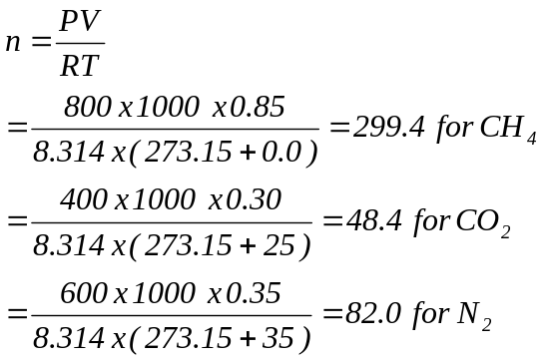
Total number of moles = 429.8 moles

- Mass of each component in the mixture.( 4.5 points)
For CH_{4,} Mass = 299.4 moles x 16 g/mole = 4790 g.
For CO₂, Mass = 48.4 moles x 44 g/mole = 2130 g
For N₂, Mass = 82.0 moles x 28 g/mol = 2295 g
Total mass = 9215 g

- Mass fraction of CO₂ in the mixture.(2 points)
Mass fraction of CO₂ = 2130/(9215) = 0.231

- Mole fraction of CH₄ in the mixture. (2 points)
Mole fraction of CH₄ = 299.4/(429.8) = 0.697

- Pressure of the mixture after heating to 400 K. (4 points)
Pressure of mixture = nRT/V
= 429.8 moles x 8.314 J/(mol K) x 400 K /(1.0 m³)
= 1.429 x 10⁶ Pa

- Partial pressure of CH₄ after heating to 400 K (3 points)
Partial pressure of CH4 = (mole fraction of CH4) x Total pressure
= 0.697 x 1.429 x 10⁶ Pa
= 0.996 x 10⁶ Pa.

PROBLEM II (30 points)
PART A: A metal has a molar mass M=56kg/kmol and an FCC crystal structure. The density of the metal is 5812kg/m³.
- Determine the closest interatomic distance. (7 points)
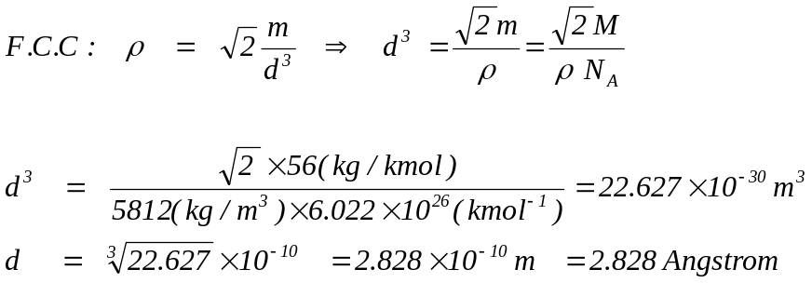

- Determine the number of atoms contained in a (4cmx2xcmx2cm) bar of this metal. (8 points)
Method (I):
Volume of the bar: V_{bar} = 16cm³ = 16x10⁻⁶ m³
Volume of a unit cell V_{cell}= a³ = (2^{1/2}.d)³ = 64x10⁻³⁰ m³
➔ Number of unit cells in the bar: V_{bar}/V_{cell} = 25x10²² unit cells.
➔ For FCC, each unit cell contains 4 atoms, therefore:
number of atoms= 4x25x10²² = 10²⁴ atoms

Method (II):
Volume of the bar: V_{bar} = 16cm³ = 16x10⁻⁶ m³
Mass of the bar: m_{bar} = ρ/ V_{bar} = 92.922x10^{–3} kg
Number of moles in the bar: n_{m}=m_{bar} /M=(92.992x10^{–3})/56 =1.661x10^{–3}kmol
= 1.661 mol.
Number of atoms in the bar: 1.661 x 6.022x10²³=10²⁴ atoms

PART B: Using the Lennard-Jones model, determine the following for Argon (Ar):
- The minimum potential. (5 points)
φ_{min}=-ε
Textbook: ε/k=118.1K ➔ ε= 163x10⁻²³ J ➔ φ_{min} =-163x10⁻²³ J

- The magnitude of the force at the minimum potential. (5 points)
F=0 N (Equilibrium)

- The distance between two atoms at the minimum potential. (5 points)
At equilibrium: r=r_{o}=2^{1/6} σ
Textbook: b_{o} = (2πN_{A} σ³)/3=0.054 m³/kmol➔ σ³=42.815 x10⁻³⁰ m³
- σ=3.498x 10^{–10} m
- r_{o}=2^{1/6} σ=3.926x 10^{–10} m
= 3.926 Angstrom

PROBLEM III (25 points)
The following data is available on properties of water.
Temperature  (ºC) | Pressure  (MPa) | Specific Volume  litres/kg
Temperature  (ºC) | Pressure  (MPa) | Liquid | Vapour
340 | 14.59 | 1.638 | 10.80
350 | 16.51 | 1.740 | 8.813
360 | 18.65 | 1.893 | 6.945
370 | 21.03 | 2.213 | 4.925
374.136 | 22.09 | 3.155 | 3.155
2.5 kg of pure water is placed in a 10 litres vessel with rigid walls. The vessel is heated to 350 ºC and maintained at that temperature for a long time. From the given information:
- Calculate the density of water (in kg/m³) at the critical point.(6 points)
Critical density = 1/ (Critical specific volume) = 1/(3.155 x 10⁻³ m³/kg)
= 317 kg/m³

- Calculate the specific volume of the vapour-liquid mixture in the vessel.(6 Points)
Specific volume of the vapour-liquid mixture = 10 litres/(2.5 kg)
= 4.0 litres/kg

- Calculate the mass of the liquid phase in the vessel at 350ºC. (6 Points)
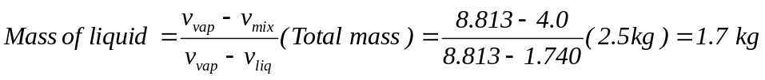

- Estimate the temperature (within ±5 ºC) to which this vessel should be heated so that only half of the water mass would remain in the liquid phase. (7 Points)
At 350 ºC the fraction of mass in liquid phase is 1.7/2.5 = 0.68
At 360 ºC the fraction of mass in liquid phase =
(6.945 – 4.0) / (6.945 – 1.893) = 0.58
At 370 ºC the fraction of mass in liquid phase =
(4.925 – 4.0) / (4.925 – 2.213) = 0.34

0.50 fraction of mass in liquid phase will occur between 360 ºC and 370 ºC. Therefore, the answer is 365 ºC.

Note: An alternate way to estimate this temperature is to look at the average of specific volumes of liquid and vapour. When half of the mass is in each phase, the specific volume of the mixture is equal to the average of the specific volumes of liquid and vapour. We know that the specific volume of the mixture is 4.0 l/kg. The average of liquid and vapour specific volumes is 4.419 at 360 ºC and 3.569 at 370 ºC. $.0 lies between these two values and therefore the temperature is between 360 ºC and 370 ºC.

PROBLEM IV (25 points)
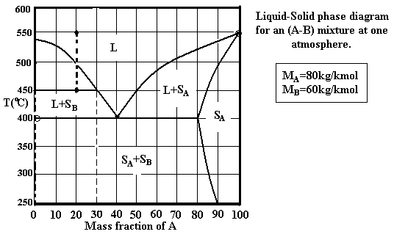
Using the above diagram, answer the following:
- What is the normal boiling point of A? (2 points)
T=550ºC

- What is the maximum solubility of A in B? (2 points)
0%

- A mixture consisting of 2.4kg of B and 0.6 kg of A is held at a temperature T=550ºC. Name the phases present. (3 points)
Liquid
w_{A} = 0.6/(0.6+2.4)=0.2 or 20wt%

- The above mixture is cooled down to a temperature T=450ºC.
    - Name the phases present. (2 points): Liquid + S_{B}

    - State the mass composition of all phases. (3 points) L (30%A)
S_{B} (0%A or 100%B)

(iii)State the molar composition of all phases. (5 points) S_{B} (0mol%A)
0.3kg A n_{A}=0.3/80=0.00375 kmol
Liquid: Consider 1kg ➔ ➔
0.7kg B n_{B}=0.7/70=0.01kmol

➔ x_{A}= 0.00375/(0.00375+0.01) ≈ 27.3mol%A

(iv) Determine the mass of each phase. (5 points)
Lever rule: m_{L}/m_{t} = (20-0)/(30-0)=2/3 ➔ m_{L}=2*m_{t}/3= 2kg
m_{SB} = m_{t} – m_{L} =1kg

(v) Determine the mass of A in the liquid phase. (4 points)
m_{L} =2kg
w_{A} =30wt%A
➔ mass of A in the liquid is 0.3x2=0.6kg.

